

This report
describe
s

the process which will be
used for creating the Crew Logistic System

Final Project Report

CS6P05 Project

Name:

Arkadiusz Grudzien

ID Number:

20001306

Date:

Sunday, 08 January 2023

Module leader
:

Dr.

El
a

Homayounval
a

First
Supervisor:

Victor Sowinski
-

Secon
d Supervisor
:

Sandra Fernando

Table of Contents
Declaration 3
Abstract 4
1: Introduction 5
1.1 Project topic and rationale 5
1.2 Projects Aims and Objectives 5
1.3 Methodology 6
Actor: Admin 9
Actor: Admin 9
Actor: Admin 9
Use case: Login 9
Use case: Logout 10
Use case: Send job Actor: Admin 10
Actor: Admin 11
Chapter 2 Background Research 11
2.2 Evaluation of related products/solutions 13
2.3 Scope of the project 14
2.4 Tools/solutions selected to use in the project 14
Chapter 3 Requirements Analysis 16
4.1 Database 17
4.2 Basic Software Logic 18
4.3 User Interface 19
Chapter 5. Summary and Future Work 26
References 27
Bibliography 27

Declaration
PLAGIARISM
You are reminded that there exist regulations concerning plagiarism. Extracts from these regulations are printed below. Please sign below to say that you have read and understand these extracts:
Student signature: Arkadiusz Grudzien Date: 08/01/23
This header sheet should be attached to the work you submit. No work will be accepted without it.

Extracts from University Regulations on Cheating, Plagiarism and Collusion
Section 2.3: "The following broad types of offence can be identified and are provided as indicative examples…
- Cheating: including taking unauthorised material into an examination; consulting unauthorised material outside the examination hall during the examination; obtaining an unseen examination paper in advance of the examination; copying from another examinee; using an unauthorised calculator during the examination or storing unauthorised material in the memory of a programmable calculator which is taken into the examination; copying coursework.
- Falsifying data in experimental results.
- Personation, where a substitute takes an examination or test on behalf of the candidate. Both candidate and substitute may be guilty of an offence under these Regulations.
- Bribery or attempted bribery of a person thought to have some influence on the candidate's assessment.
- Collusion to present joint work as the work solely of one individual.
- Plagiarism, where the work or ideas of another are presented as the candidate's own.
- Other conduct calculated to secure an advantage on assessment.
- Assisting in any of the above.
Some notes on what this means for students:
- Copying another student's work is an offence, whether from a copy on paper or from a computer file, and in whatever form the intellectual property being copied takes, including text, mathematical notation and computer programs.
- Taking extracts from published sources without attribution is an offence. To quote ideas, sometimes using extracts, is generally to be encouraged. Quoting ideas is achieved by stating an author's argument and attributing it, perhaps by quoting, immediately in the text, his or her name and year of publication,
2
e.g. "e = mc (Einstein 1905)". A references section at the end of your work should then list all such references in alphabetical order of authors' surnames. (There are variations on this referencing system which your tutors may prefer you to use.) If you wish to quote a paragraph or so from published work then indent the quotation on both left and right margins, using an italic font where practicable, and introduce the quotation with an attribution.

Abstract

This project requires the development of a web-application system for the event company Pinnacle Crew. Pinnacle have been specializing in providing crew for corporate events. They have systems and tools in place for maintaining their business but are missing valuable features meaning they don’t currently have a system that can efficiently maintain organisation of the employed crew within their company. The system currently in use is a simple SMS system, which is not convenient from the crew's perspective. The current system functions in the following way: The admin (officer) sends an
SMS to each crew member detailing: Job Number, Date, Time, Required Amount of Crew, Shift Duration, Client’s Company Name, Contact Number on site, Additional Notes. When the crew receive the message, the user must reply with 'YES' or 'NO' and supply the job number ID. The confirmation, if the crew member is assigned to the job, is called 'CREW LIST'. This is sent usually 24h before starting the job. The crew list consists of all the information about the job, phone numbers and names of all the members which they have been assigned to the specific job. The idea for the new system is to substitute the current inconvenient system to web-application where crew members can effectively communicate with the office about the jobs. The employers also will see the details about the jobs, their details etc.

1: Introduction

1.1 Project topic and rationale

The project topic is a web application called Crew Logistic System. The functionality is like already existing system such as Employee Management System. The motivation which has been pushed me to create the project is that I am part-time employee of the company. During work at the company, I have realized what are the problems and how current system is inconvenient from the crew’s perspective. I have decided to develop a web application to solve the issues.
The software will be designed to help the company Pinnacle Crew to manage their crew members and jobs. The project is interesting because it is a real-life project, and it is a good opportunity to learn how to develop a web application. The problem in hands is that the company Pinnacle Crew is using a SMS system to manage crew member. The jobs are events that the companies of events are organizing, and the crew members are the people that are working on the events. The admin sends jobs to specific crew members. The crew members must confirm or reject by doing specific action in the app. The usefulness of the app is that it will help the company to manage their crew members and jobs more efficiently.

1.2 Projects Aims and Objectives

1.2.1 Aims:

The primary aim of this project is to design and implement a full web application system that will improve communication between the office administrator and crew members. The current system has several inconveniences that need to be addressed, with the most critical being the crew's difficulty in tracking their jobs and hours.
The new system will address this issue by automatically counting and storing all the hours worked by each crew member and all jobs completed. Instead of the administration office sending messages to the crew, the system will now provide a platform for creating and uploading job details to be seen by the crew. Crew members can then accept or decline available jobs, streamlining the job allocation process and making it more efficient.
To support these new capabilities, the system will feature individual user accounts for administrators and crew members. These accounts will store important user details such as documents, avatars, photos, and other necessary information.
The system will be designed using modern technologies, including Spring Boot as a backend system. All system logic will be written and executed on the server where the application is deployed. By leveraging these cutting-edge technologies, the system will provide a user-friendly interface that is easy to use and navigate for both administrators and crew members alike. Ultimately, this project aims to create a more efficient and streamlined job allocation process that will enhance the productivity and effectiveness of the organization.

1.2.2 Objectives:

Write a full backend system in Spring Boot including following functionalities:
Account where user will be login in. The user will login as an admin will see the dashboard as a landing page. The dashboard will consist of all the brief information about the activities in the system such as:
- Who recently joined to the company.
- Recent added jobs (it must be because there will be more than one admin (officer)) o Ability to redirect to those sections in the system from dashboard page.

➢ The admin also will have following sections:
User management – admin can add another user to the system choosing role as admin or crew member. Also, admin will have the ability to edit details, delete user and suspend account.
Jobs management – admin can send a particular job to chosen crew members so only crew members with required skill wills receive a job where the skills are necessary.
Profile – despite who is logged in (admin or crew member) will have the ability to change the details, uploCrew Logistic System - Use Case Model ad documents, change avatar etc.
Logout – for invalidate a session for logged user.
The system also will have a feature where the user will receive an email that his/her account has been created. The user must click on the link in the email to activate their account.
Make a design for frontend in Figma and then create it in React JS.

1.3 Methodology

The methodology which I am going to use for this project is called Agile methodology. Agile is a method for creating a software. It’s a chain between rapid development and deployment.
This process emphasizes flexibility and rapid iteration. It is based on the principles outlined in the Agile Manifesto, which values individuals and interactions, working solutions, and customer collaboration over processes and tools.
Agile development is characterized by short development cycles, called "sprints," which typically last a few weeks. During each sprint, developer works on a specific set of features or tasks. The creator or team uses regular meetings, called "scrum" meetings, to communicate progress and address any issues that may arise.
One of the key principles of agile development is the concept of "iterative development," in which the creator continually refines and improves the product through multiple cycles of development (Figure 1). This allows the developer to quickly incorporate feedback from users and stakeholders, and to adapt to changing requirements or priorities.
Overall, the goal of agile development is to deliver high-quality products to customers in a timely and efficient manner, while also fostering a culture of continuous learning and improvement.

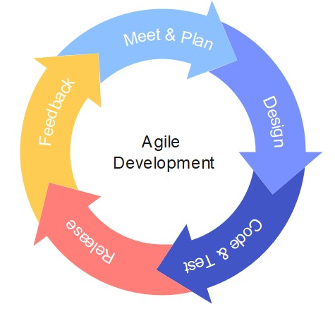
Figure 01: Agile Development Process

1

Agile Development Process

1.3.1 Use Case Model

Use Case model performs the functions which will be available in the system. During the process of developing the function might be reduced or expanded.
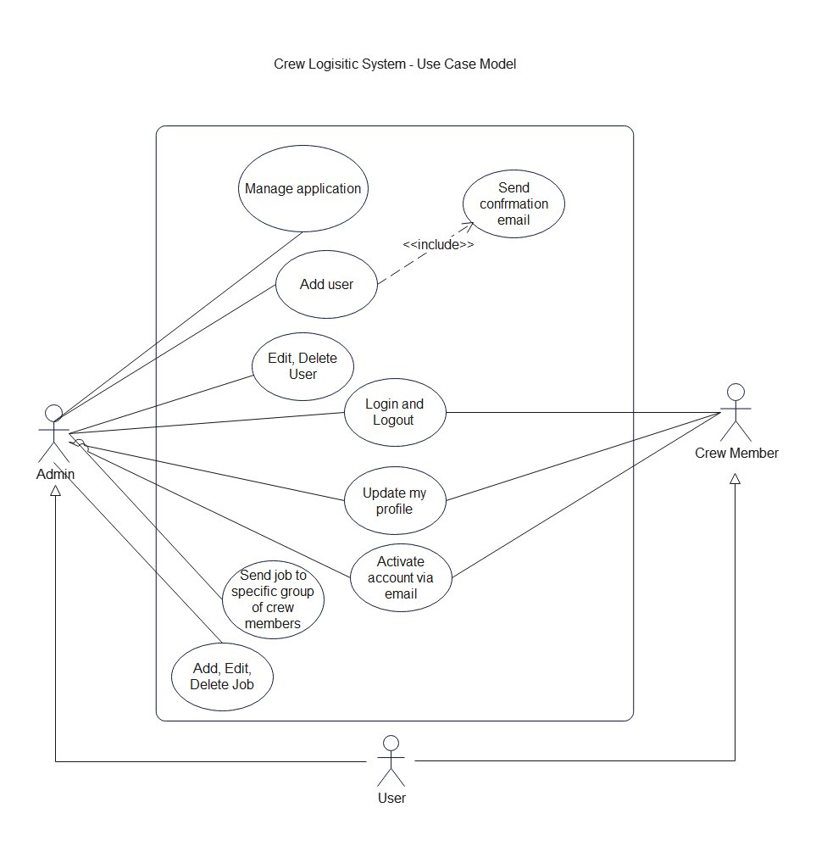Figure 02: Crew Logistic System - Use Case Model

1.3.2 High Level Use Case Descriptions

Use case: Manage application
Actor: Admin
Description:
The administrator who logs into the system is responsible for maintaining the application and ensuring that all functions are working correctly. They must also regularly check the logs to identify any potential issues with the system's backend. If any errors are discovered, it is crucial that the administrator immediately notifies the development team responsible for the application. By doing so, they can quickly work to identify and resolve the problem to minimize any negative impact on the system's overall performance. By diligently performing these tasks, the administrator helps to ensure that the system is operating smoothly and providing the necessary functionality to support the organization's HR management processes.

Use case: Add new user
Actor: Admin
Description:
When the administrator logs into their account, they can navigate to the section where new users can be created. From there, they will be prompted to fill out a form with details about the new user, including their name, email address, job title, and other relevant information. Once the form is completed, the administrator can then click on the "create new user" button to submit the information.
Upon submission, the system will automatically send a notification email to the new user's email address. This email will provide information about their login credentials, as well as any other relevant information about their new account. By following this process, the administrator can quickly and easily add new users to the system, providing them with the necessary access to perform their job responsibilities within the organization.

Use case: Edit, Delete User
Actor: Admin
Description:
Once an administrator logs into their account, they have the ability to modify user details for both administrative and crew members. Depending on the necessary action, the administrator can click on the appropriate "edit" or "delete" button.
If the administrator clicks on the "edit" button, they will be presented with a form that is pre-populated with data from the database. From here, the administrator can make changes to the user's details as needed. Once the modifications have been made, the administrator can click on the "save" button to update the user's information in the system.
Alternatively, if the administrator clicks on the "delete" button, the chosen user will be removed from the system. Before deleting the user, the administrator may be prompted to confirm the deletion to avoid any unintentional removal of important user data.
Through these capabilities, the administrator can easily make modifications to user information as needed, ensuring that the system remains up-to-date and accurate for all users.

Use case: Login
Actor: Admin, Crew Member
Description:
Users can access the system by logging in through the main page of the application using their email and password. Once the correct login credentials are provided, the user is redirected to their respective dashboard, which will vary based on whether the user is an administrator or a crew member.
To ensure the security of the system and user information, the application uses JSON Web Tokens (JWTs). When a user logs in, the system generates a JWT, which is a string that contains all of the necessary information about the user. The JWT acts as a session for the user and is stored in the browser to enable the user to continue accessing the system without needing to enter their login credentials repeatedly.
By using JWTs, the system can maintain secure and efficient user sessions, providing a seamless experience for the user. Additionally, JWTs enable the system to keep track of each user's permissions, roles, and access levels, ensuring that all user activities and data remain secure and protected from unauthorized access.

Use case: Logout
Actor: Admin, Crew Member
Description:
When a user needs to log out of the system, they can do so by clicking on the appropriate button on the navigation bar. Once the user has clicked on the logout button, the system automatically deletes the JSON Web Token (JWT) associated with that user.
By automatically deleting the JWT upon logout, the system ensures the security of the user's account and information. This measure helps prevent unauthorized access to the user's data, even if their device is lost or stolen. Additionally, deleting the JWT when a user logs out helps prevent any future attempts to access the user's account with an outdated token, further enhancing the system's security and protecting user information.

Use case: Update my profile
Actor: Admin, Crew Member
Description:
Users have the ability to update their profile information by clicking on the appropriate button available on the sidebar. From there, users can edit their personal details and upload any relevant documents, such as a passport or other required credentials.
The ability to update profile information and upload documents is an essential feature of the system, enabling both administrators and crew members to maintain their accounts and ensure that their personal information is up-to-date and accurate.
The specific types of documents required for upload will be determined in future development, but this feature is expected to greatly enhance the user experience by providing a centralized location for all required documentation. Additionally, the ability to update profile information will enable users to easily change their personal details, making the system more flexible and user-friendly.

Use case: Activate account via email
Actor: Admin, Crew Member
Description:
Once a user account is created, the user will receive a confirmation link via email. To complete the account creation process, the user must click on the received link, which will redirect them to the login page of the system.
This verification step is an important security feature that helps ensure that only authorized users can access the system. By requiring users to verify their email addresses, the system helps prevent fraudulent or unauthorized access to user accounts and information.

Use case: Send job
Actor: Admin
Description:
One key feature of the system is the ability for administrators to create groups from a list of available crew members and then assign specific jobs to those groups. This feature provides a high degree of flexibility and ensures that only qualified crew members are assigned to a given job.
By creating groups, administrators can easily select crew members with the required skills and experience to perform a particular job. This helps ensure that each job is completed effectively and efficiently, without any unnecessary delays or setbacks. In addition, by only assigning jobs to qualified crew members, the system helps prevent errors and reduces the risk of accidents or other issues that could occur due to a lack of proper training or expertise.

Use case: Add, edit, delete job
Actor: Admin
Description:
Administrators have the ability to create, edit, and delete jobs in the system. This feature allows administrators to quickly and easily add new jobs to the system, update the details of existing jobs, and remove jobs that are no longer needed.
To create a new job, the administrator simply fills out a form with details about the job, such as the job title, description, required skills, and estimated completion time. Once the job is created, it is added to the system and made available to the crew for assignment.
If the details of a job need to be changed, the administrator can easily edit the job by selecting it from the list of available jobs and making the necessary updates. This could include changing the job title or description, updating the required skills, or adjusting the estimated completion time.
If a job is no longer needed, the administrator can delete it from the system entirely. This removes the job from the list of available jobs and ensures that crew members will no longer see it as an option for assignment.

Chapter 2 Background Research
List of similar projects which will help to make this project:
- EMS – Employee Management System
- MSS – Management Self-Service
- HRIS – Human Resource Information System
- HR – Human Resource
- HOD – Head of Department

2.1 Literature reviews on subjects related to the project.

EMS
The employee management system gives efficient way to manage work between admin work and the team. The system is designed to help the business owner specially to save money and time. The system can help for example what kind of task does specific worker. The admin via the system can assign to different assignment or/and department. The worker can efficiently apply for a holiday and the admin can accept it or reject it. The employees can add work report. Employee also can send a leave request so the employer will know this information immediately and will start to look for a substitution.
The Employee Management System is very important for the business where it runs. The data which is store in database can be accessed just for the authorized personnel with specific permissions. This is one of many important aspects during developing such as system. The system allows to have the data from the origin source which means from the employee because he/she can update the details about their self. The system provides a quick information for the admin and especially for the worker. The worker can see the work schedule, salary information, education information or contact information. This data is very useful because it allows to improve the efficiency and workflow of the business. Based on these data the admin or head of the organization can assign or reassign the specific tasks or departments or adjust the salary and the work schedule etc. [1]

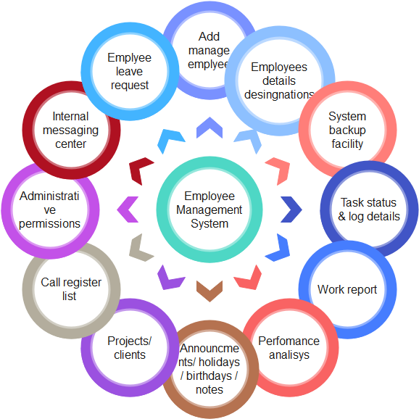Figure 03: Example of functions for Employee Management System

MSS - Management Self-Service

Management Self-Service (MSS) is a software platform designed to empower managers with the ability to handle their own administrative tasks, such as employee records management, time and attendance tracking, and performance evaluations. By using an MSS system, managers can access important employee data and perform various tasks without relying on HR staff or other administrative personnel.
An MSS system is often integrated with a larger HR management system, such as Oracle HCM, to provide a more comprehensive platform for managing the entire employee lifecycle. Oracle HCM's MSS module, for example, offers a range of self-service features for managers, including the ability to view employee records, submit time-off requests, and approve timesheets (Oracle, n.d.).
The use of MSS systems can provide several benefits to organizations, including increased efficiency, reduced administrative costs, and improved data accuracy. By empowering managers to handle administrative tasks independently, HR staff can focus on higher-level strategic tasks and initiatives.

To successfully implement an MSS system, organizations must ensure that their managers are trained and equipped to use the system effectively. They must also ensure that the system is properly integrated with other HR management tools, and that all data is secure and compliant with applicable regulations.
In conclusion, Management Self-Service can provide significant benefits to organizations looking to optimize their HR management processes. By implementing an MSS system, organizations can increase efficiency, reduce costs, and improve the accuracy of their employee data.

HRMS - Human resource management system
Human resource management system refers to the systems and processes that interface between human resources Management (Human Resource Management) and Information Technology. It regards human resource management as a discipline with Basic HR activities and processes, especially in the field of information technology The programming of data processing systems evolves into standardized routines and packages ERP (Enterprise Resource Planning) software. [2]

HRIS

An HRIS is a software platform designed to automate and streamline various HR tasks, such as payroll management, benefits administration, employee record-keeping, and performance management. This type of system can also offer tools for recruitment, onboarding, training and development, and compliance tracking. The main goal of an HRIS is to increase efficiency and reduce the administrative burden on HR staff. With an HRIS, organizations can better manage employee data, reduce errors, and provide more timely and accurate information to employees and management. Additionally, an HRIS can support strategic decision-making by providing HR leaders with real-time data and analytics on employee performance and organizational trends. Examples of popular HRIS systems include Workday, SAP SuccessFactors, and Oracle HCM. Mathew, A., Kumar, A., & Nair, B. K. (2018).

2.2 Evaluation of related products/solutions

Employee Management System example 1
I have listed below few similar products which they are available online. smb.co.uk
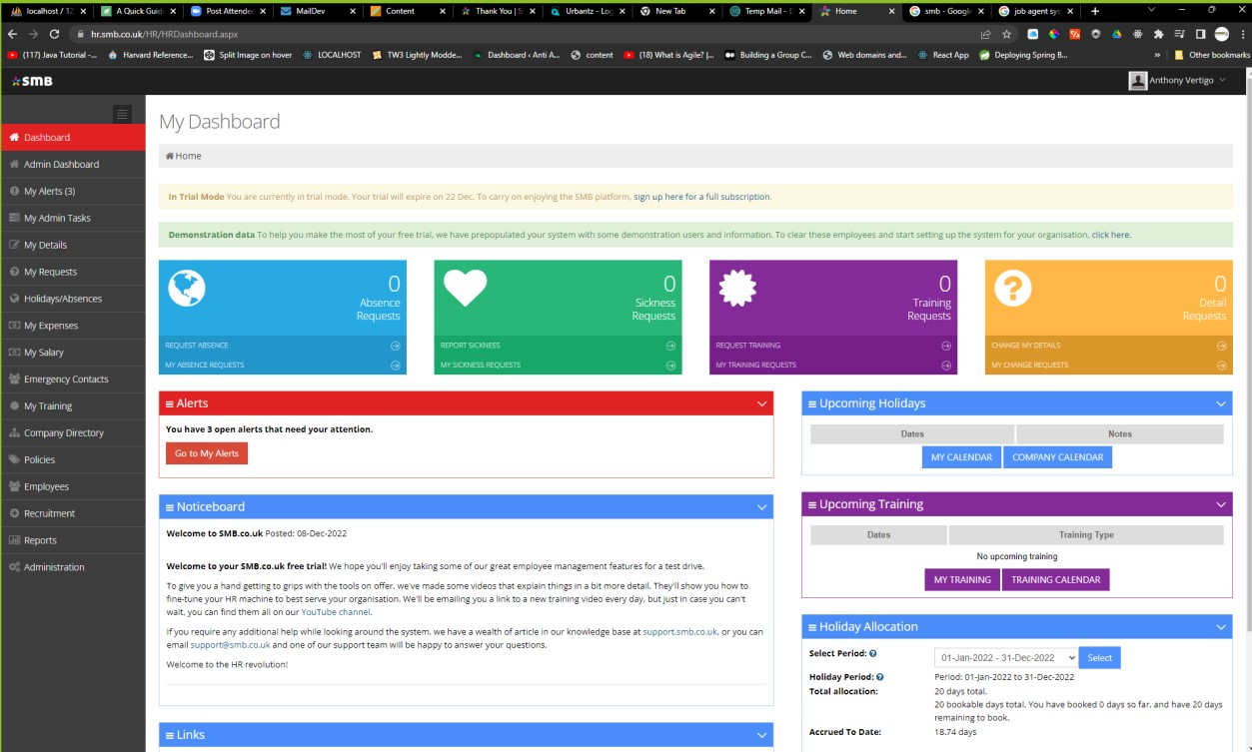Figure 04: Dashboard and Navbar of SMB

SMB helps for employers to manage data about their employees. It has friendly user interface and intuitive user experience. I will use it to inspire and adapt some features and solution from this platform.

Employee Management System example 2
The figure below preform the basic Employee Management System found in GitHub repository.

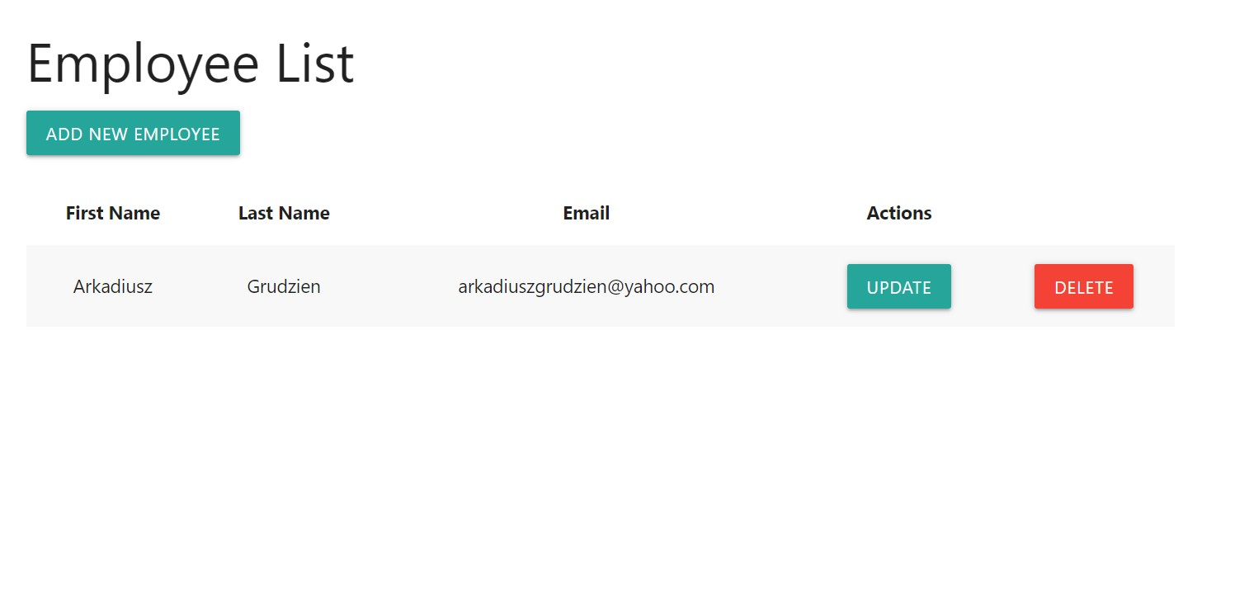

The project is a basic EMS system where user can add an employee. Ones the button “Add new employee” is clicked the page is redirected to form. The form contains fields about new employee who can be added by clicking “Add employee”. The employee can be also edited and deleted form the database. The system using MySQL server. This project allows me to have a basic concept for my application. This project has been created in Java 11 and Spring Boot. I can see what functions has been created and see what I can use to my project. The fronted has been created in Thymeleaf the template engine for Spring Boot. In my case therefore will be created in React which is more convenient end efficient.

2.3 Scope of the project

Goals:
Login system where admin or crew member will be logging in
Dashboard where admin can see what has been done in the system such as: new crew is available to work:
Adding new jobs and users.
Deleting, editing jobs and users.
Profile section where user can edit details, add documents etc.

2.4 Tools/solutions selected to use in the project

2.4.1 Spring Boot – backend

Spring Boot is a Java-based framework used to build standalone, production-grade applications. It is designed to simplify the process of developing and deploying applications by providing a set of tools and libraries that make it easy to create and run a new application.
Some of the key features of Spring Boot include:
- An embedded servlet container (such as Tomcat or Jetty) that makes it easy to run the application as a standalone Java application.
- Auto-configuration of Spring beans based on the presence and configuration of certain classes in the classpath. This means that you can create a simple Spring application without writing any configuration code.
- Support for various types of database and messaging technologies out of the box, including JDBC, JPA, Hibernate, and JMS.
- A command-line tool that makes it easy to create and run Spring Boot applications.
- Support for easy deployment to various cloud platforms, such as AWS and Heroku.
Spring Boot is a powerful tool for building Java-based applications that are easy to develop and deploy.

2.4.2 React – frontend

React is a JavaScript library for building user interfaces. It was developed by Facebook and is often used for building single-page applications (SPAs) and mobile applications.
One of the key features of React is that it allows developers to create reusable components that can be easily combined to create complex user interfaces. This makes it easy to build large, interactive applications that can be easily maintained and scaled over time.
React is designed to be fast and efficient, with a virtual DOM (Document Object Model) that allows it to update only the parts of the page that have changed, rather than redrawing the entire page. This makes it well-suited for applications that need to handle large amounts of data and update the user interface in real-time.
In addition to its core library, React also has a number of complementary tools and libraries, such as React Router for managing application routing, and Redux for managing application state.

2.4.3 MySQL

MySQL is a popular open-source relational database management system (RDBMS). It is widely used for managing data in web and mobile applications, and is known for its reliability, flexibility, and ease of use.
MySQL is based on the Structured Query Language (SQL), which is a standard language for interacting with relational databases. It allows users to create, modify, and query databases, as well as control access to the data stored in them.
MySQL is designed to be fast and scalable, with a wide range of features that make it well-suited for a variety of applications. These features include support for transactions, foreign keys, views, and stored procedures, as well as support for various data types and indexes.
In addition to its core database engine, MySQL also includes a number of tools and utilities for managing and administering databases, such as the MySQL Workbench graphical interface and the mysqldump utility for backing up and restoring databases.
MySQL easily integrate with Spring Boot which makes the database convenient to use for this project. The platform can be installed additionally with phpMyAdmin. It’s a user interface for MySQL where can be done the CRUD operations.

2.4.4 Visual Studio Code

The program is a free open source code editor developed by Microsoft. This Integrated Development Environment is useful because there is variety of extensions to add for it. The most important are :
o IntelliSense – it help to write the code, its suggesting a code while typing. o Debugging support which allows to go through code and see potential issues. o Included terminal which allows to run a command straight away in the IDE.

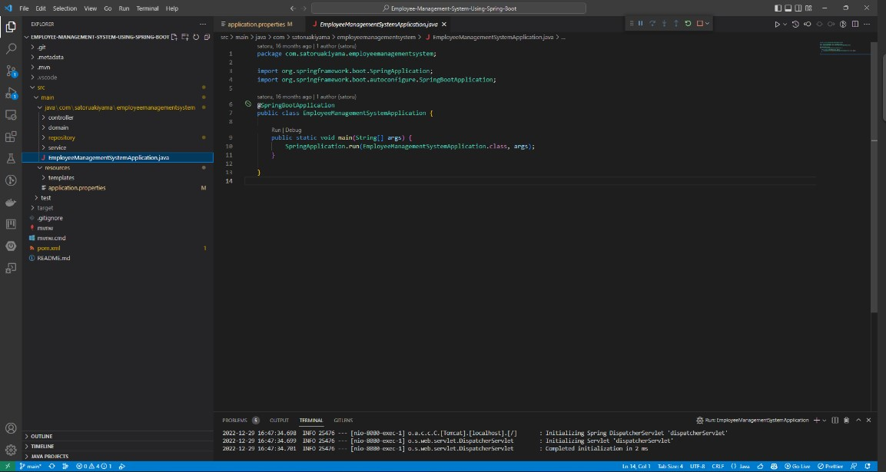
Figure 5 Visual Studio Code in action. It has intuitive user experience which helps to make projects.

Chapter 3 Requirements Analysis
A crew logistics system is a software application that is used to manage the scheduling, logistics, and support activities related to the crew of the organization called Pinnacle Crew. The main requirements are:
- Scheduling and rostering: The system should allow users to schedule and roster crew members and jobs, considering factors such as qualifications, availability, etc.
- Crew tracking and location: The system should track the location and status of crew members, including whether they are on duty or off duty.
- Crew communication and messaging: The system should provide a means for crew members to communicate with admin, such as dispatch or ground crew, and should allow for the sending and receiving of messages and alerts.
- Training and certification: The system should track and manage the training and certification of crew members, including the expiration of licenses and other qualifications.
- Reporting and analytics: The system should provide various reports and analytics to help users understand the crew logistics data and make informed decisions.
- Integration with other systems: The system should integrate with other systems that are used by the organization, such as payroll, HR, and maintenance systems.

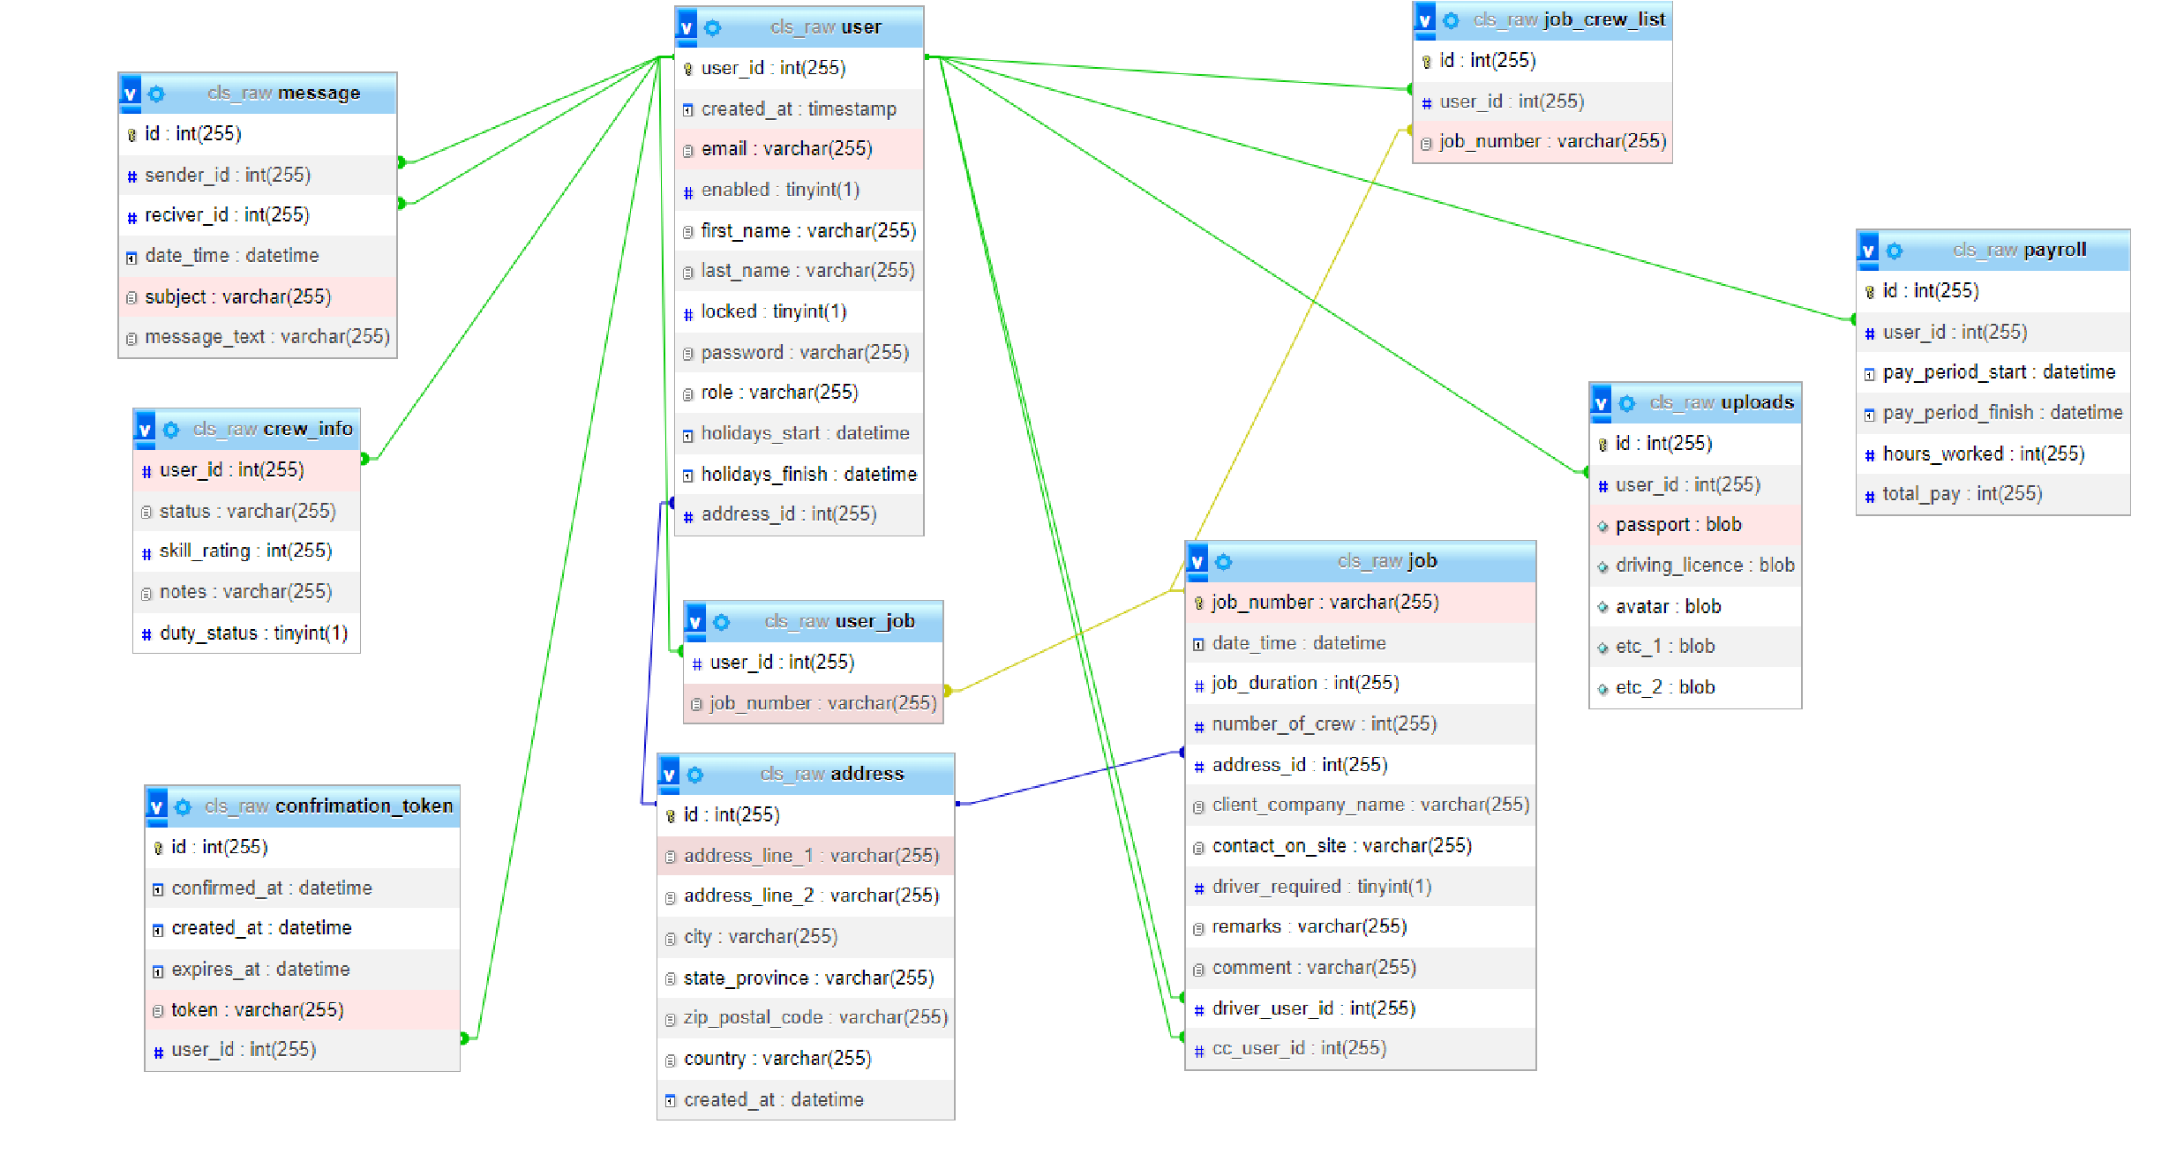Figure 05: Entity Relationship Diagram of the database

Chapter 4 Software Design.

4.1 Database

The database for the web application has been designed in phpMyAdmin. It’s a user interface for MySQL Database. The program has a database designer integrated in it so it’s easy to maintain and edit the database. In this case that the program will be written in Spring Boot, at the first instance I have designed test database. The schema will be generated in Spring Boot, but I have created test database to have a structure and base point to start write the program. For testing purposes, the database has been named the as cls_raw.

This database is a breakpoint for creating the program. During development in Spring Boot the database might be a bit different from the original because Spring Boot sometimes creating additional tables for better performance.

4.2 Basic Software Logic

The figure below performs conceptual logic of the application. The react is responsible for handle the views. Its communicating with Spring Boot (backend) via HTTP Requests which are written in JSON (Java Script Object Notations). What it means it sends objects as JSON and then Spring Boot processing by functions written in Java. The Spring JPA is responsible for communicating between Spring Boot and database which is MySQL.

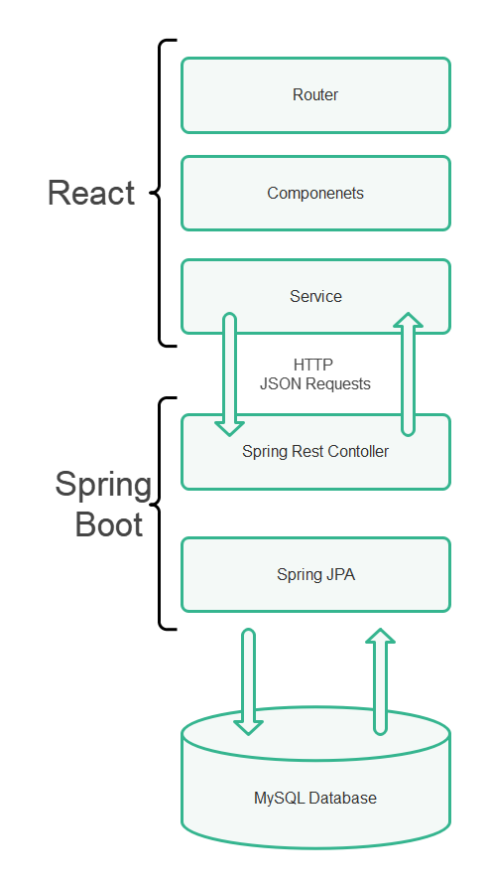
Figure 7 Conceptual Logic Diagram of the Software

4.3 User Interface
User interface website structure
Admin Site

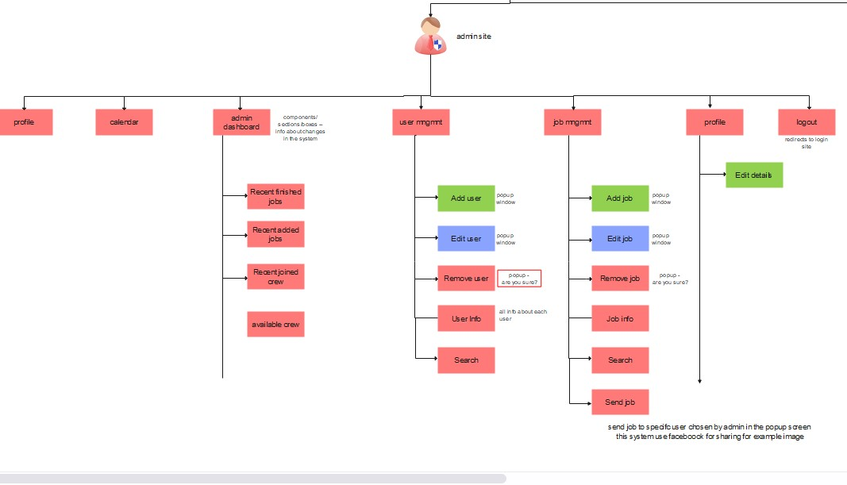
Figure 8 Application structure - admin site

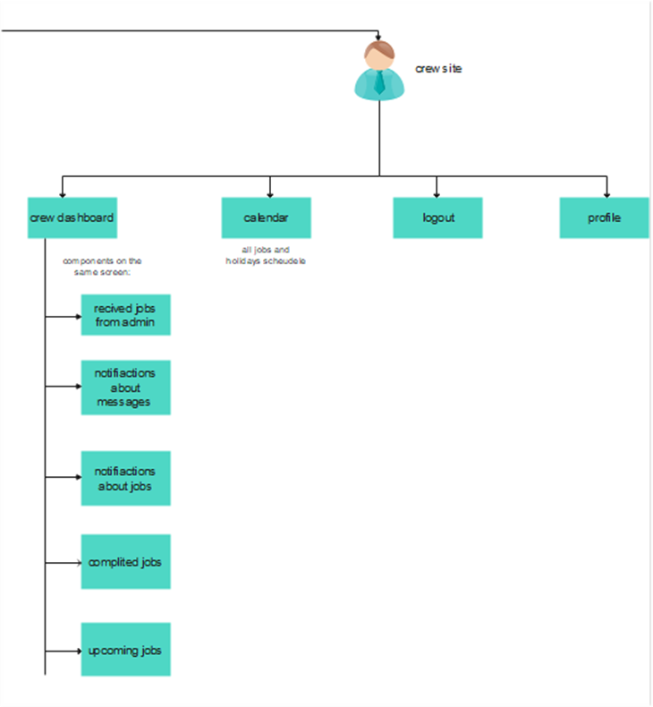
Crew Site
Figure 9 Application structure – crew site
Login Page
Login page has been created with modifying already existing template
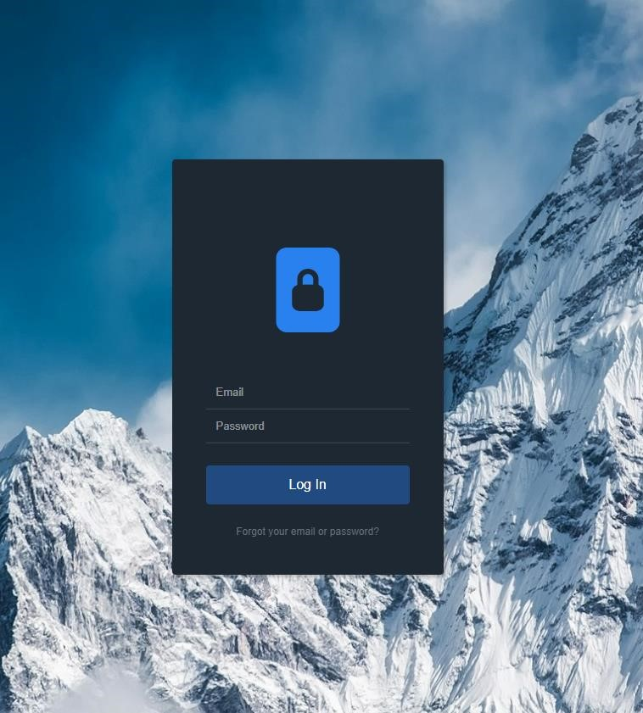
Figure 10 Login Page

This page has two fields where user can type email and password. If all data are valid the page is redirected to the view of logged user. Dashboards are different depended on who is logged in crew member or admin.

Admin Account

The design was created in Figma. Figma is a simple drag and drop software for developing user interfaces.
This dashboard will be appeared ones the admin will be logged in to his/her account. In future development will be decided what the notifications will to be.

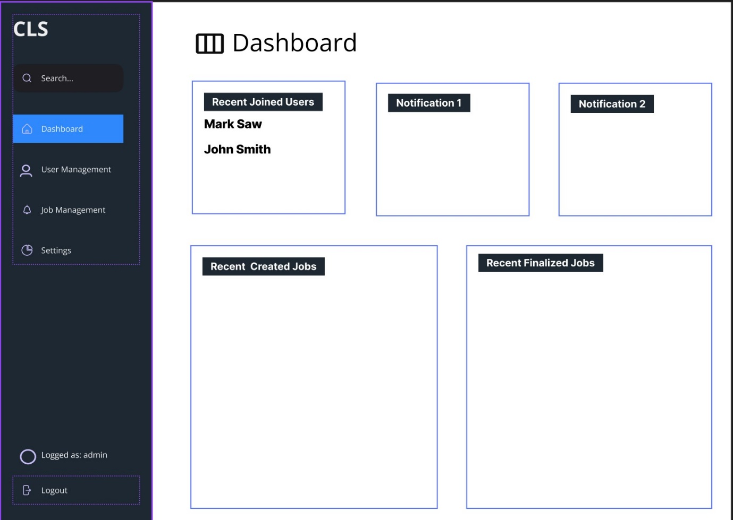
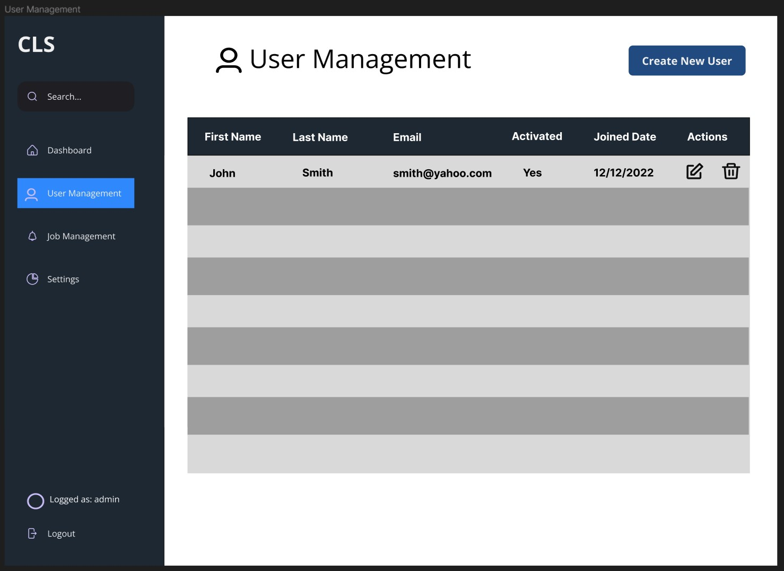
Figure 11 Admin's dashboard

Figure 13 User management view
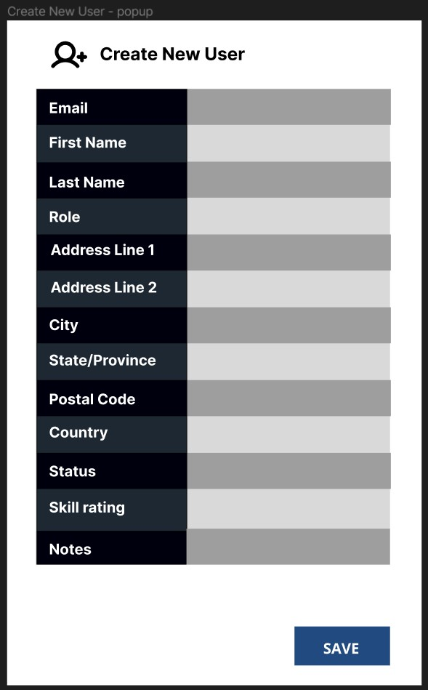
The view on the right-hand site is to create a user. The admin must click on the button “create new user” after that the window will pop up with a form to fill up. The edit view will be similar to it. The edit view will be popping up ones the button is clicked. The button is positioned in the list of users. The edit view will come up with the details from the database.

Figure 12 Create New User view >

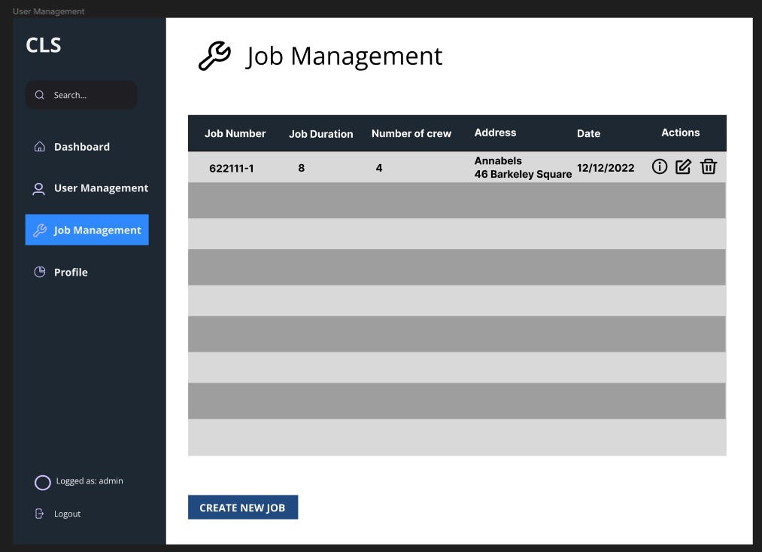
Figure 15 Job Management View
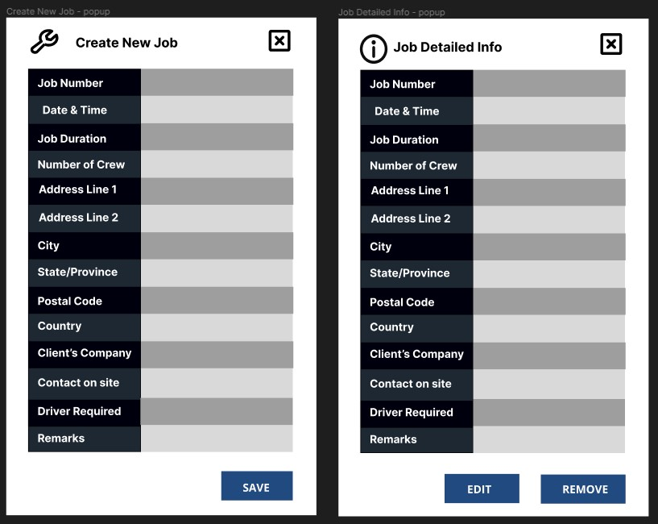

Figure 14 New Job Form and Job Detailed Info popup windows

Crew Account

This dashboard shows the overall about the completed and upcoming jobs, also about what crew member gained. Hours and pay.
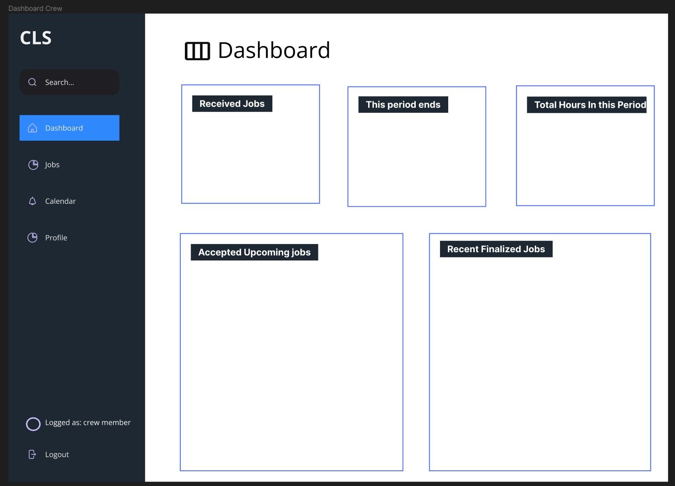
Figure 16 Dashboard of crew member

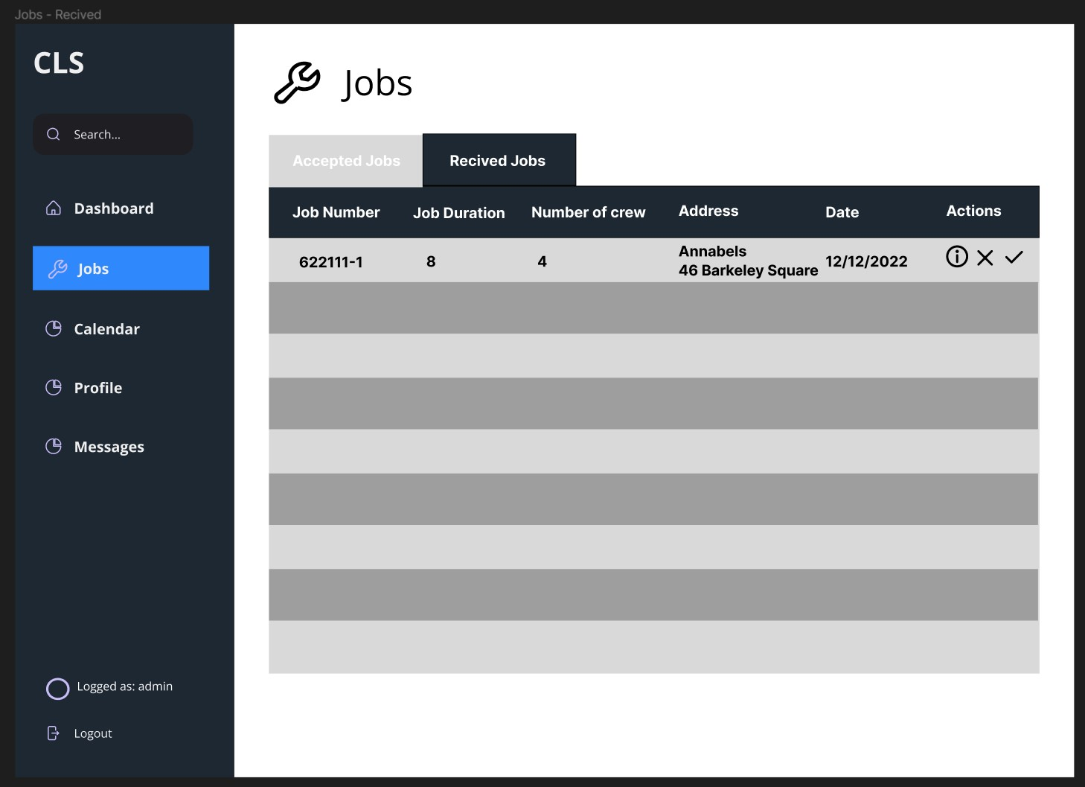

Figure 18 Received Jobs from Admin to accept or decline

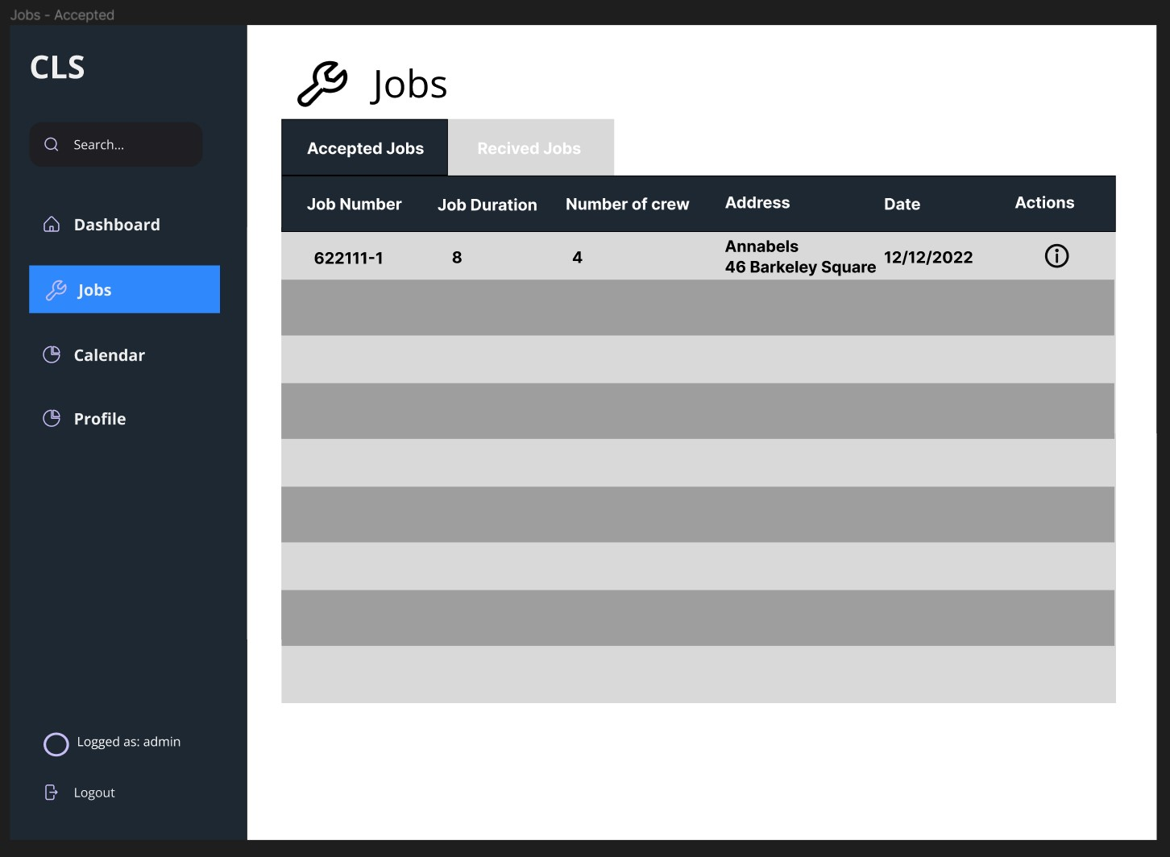
Figure 17 Accepted Jobs / Upcoming jobs for logged crew member
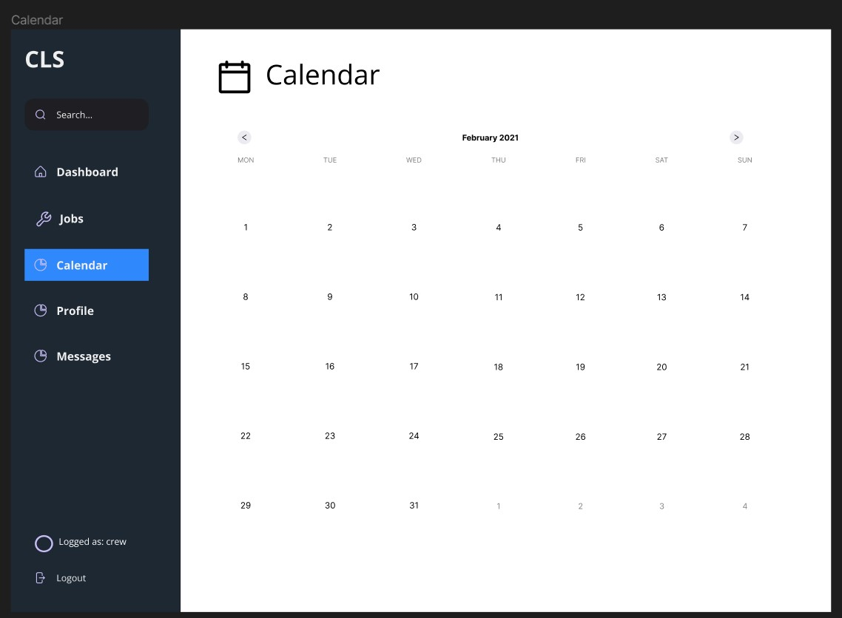

Figure 19 Planning calendar for each crew member
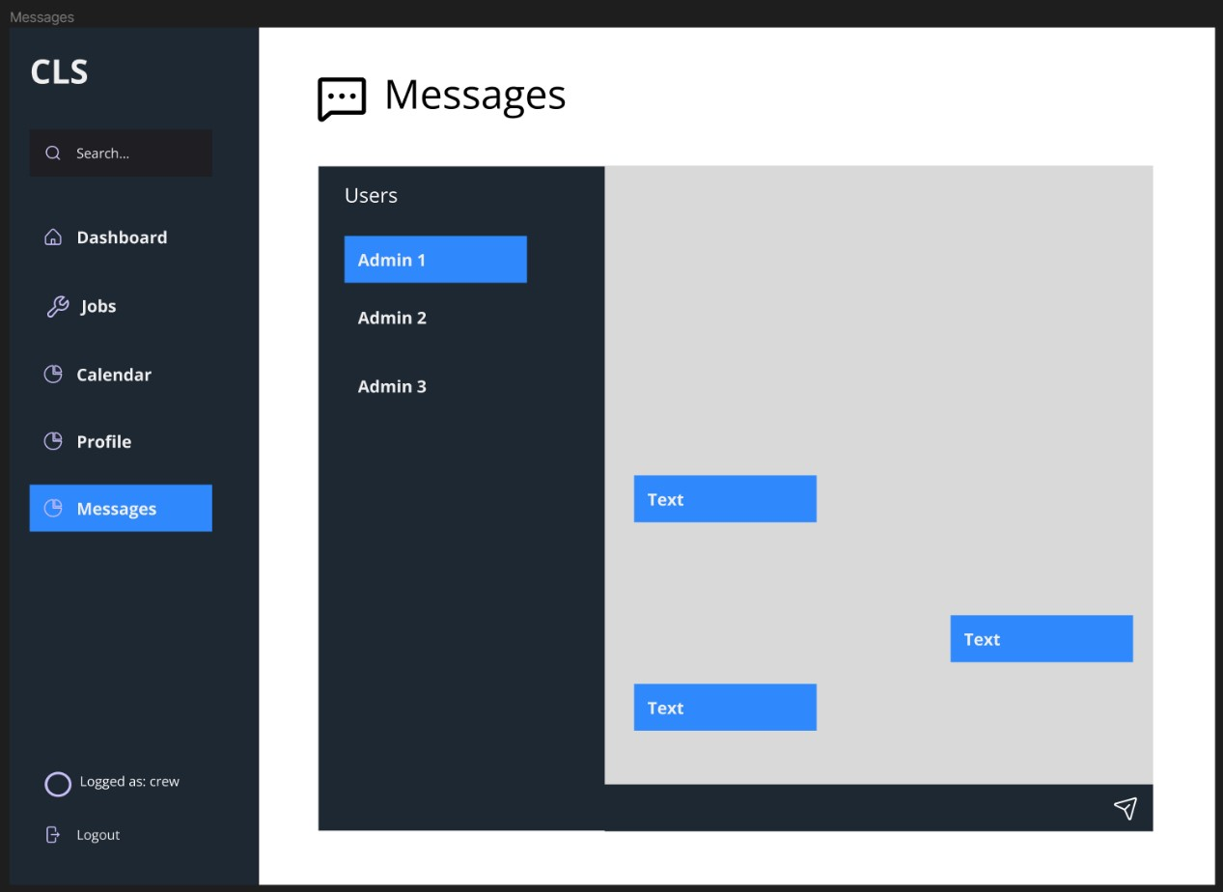

Figure 20 Conversations between admins and crew
User’s profile
The navbar of this view will be different for crew or admin but the profile section will be the same.
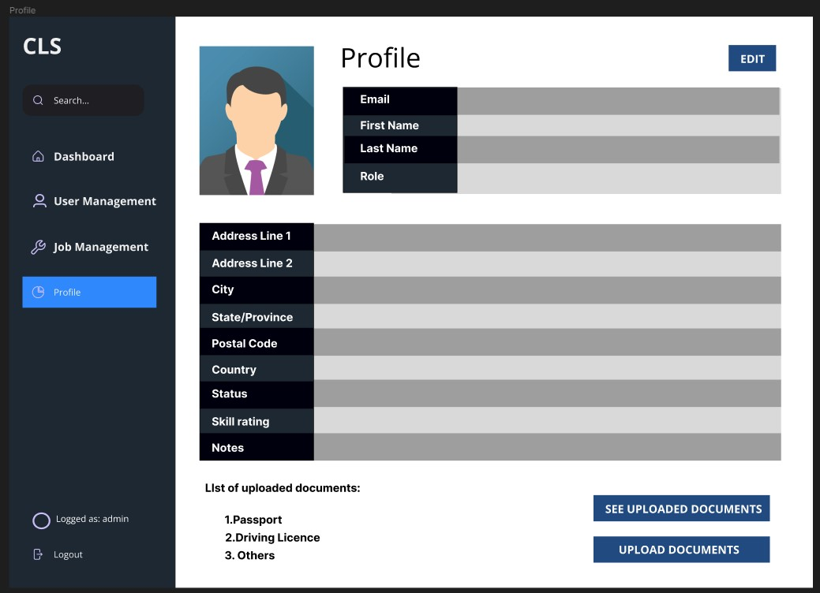
Figure 21 Profile View

Chapter 5. Summary and Future Work

The code has been already written with following functionalities:
Complete Login – the system recognizes who is logging in crew member nor admin. The system using JWT which is Json Web Token. JWT is a string which is saved on client’s computer to be able to create a session with all data for user. Its not necessary to load data from database to see if the credentials are valid.

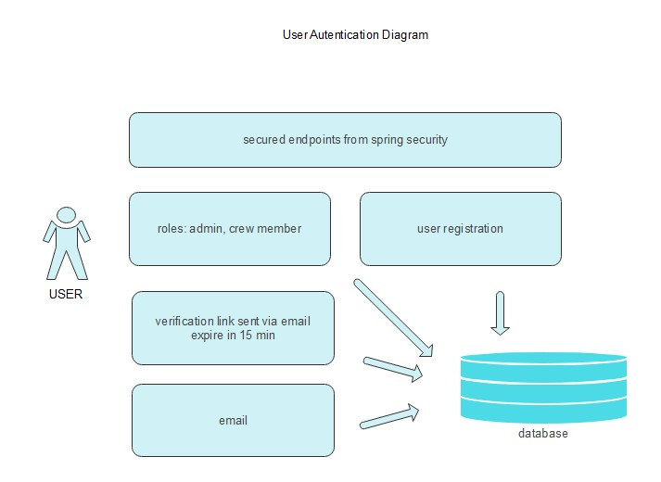
Figure 22 User Authentication diagram

Create a user – the user can be created by the admin. There is appropriate form to do that.
Confirmation Email – ones the user is created the system sends the confirmation letter for the provided email by admin. Ones the user clicks on the link provided in the email the account became activated. This all has been made for the security reasons.

What needs to still be done is to restructure the design which has been attached in this report. The design which is developed is not clear and there is a lot to make. The idea is to substitute what has been already done and apply new template in React. Is easer to find a template for the system than creating it from scratch.

References

- Diawati, Prety & Paramarta, Vip & Pitoyo, Djoko & Fitrio, Tomy & Mahrani, Wiyati. (2019). Challenges of Implementing an Employee Management System for Improving Workplace
Management Effectiveness. Available at https://www.researchgate.net/profile/TomyFitrio/publication/338216184_Challenges_of_Implementing_an_Employee_Management_S ystem_for_Improving_Workplace_Management_Effectiveness/links/5e07f14a4585159aa4a
25ba6/Challenges-of-Implementing-an-Employee-Management-System-for-Improving-
Workplace-Management-Effectiveness.pdf . Last accessed 13 December 2022

- Julie Bulmash, “Human Resource Management and Technology”, Chapter
- Oracle. (n.d.). Oracle HCM Cloud: Management Self-Service. https://www.oracle.com/human-capital-management/hcm-cloud/management-self-service/
- Mathew, A., Kumar, A., & Nair, B. K. (2018). An overview of human resource information systems (HRIS): an evolving agenda. Journal of Enterprise Information Management, 31(6), 962-980. https://doi.org/10.1108/JEIM-06-2017-0114

Bibliography

Ian Somerville 2014 Software Engineering 10th ed. Essex: Pearson.
Artemij Fedosejev. (2015). React.js Essentials. Packt Publishing.
Somnath Musib. (2022). Spring Boot in Practice. Manning Publications.
Pinyodulyajet, S., 2002. E-Logistic application.

